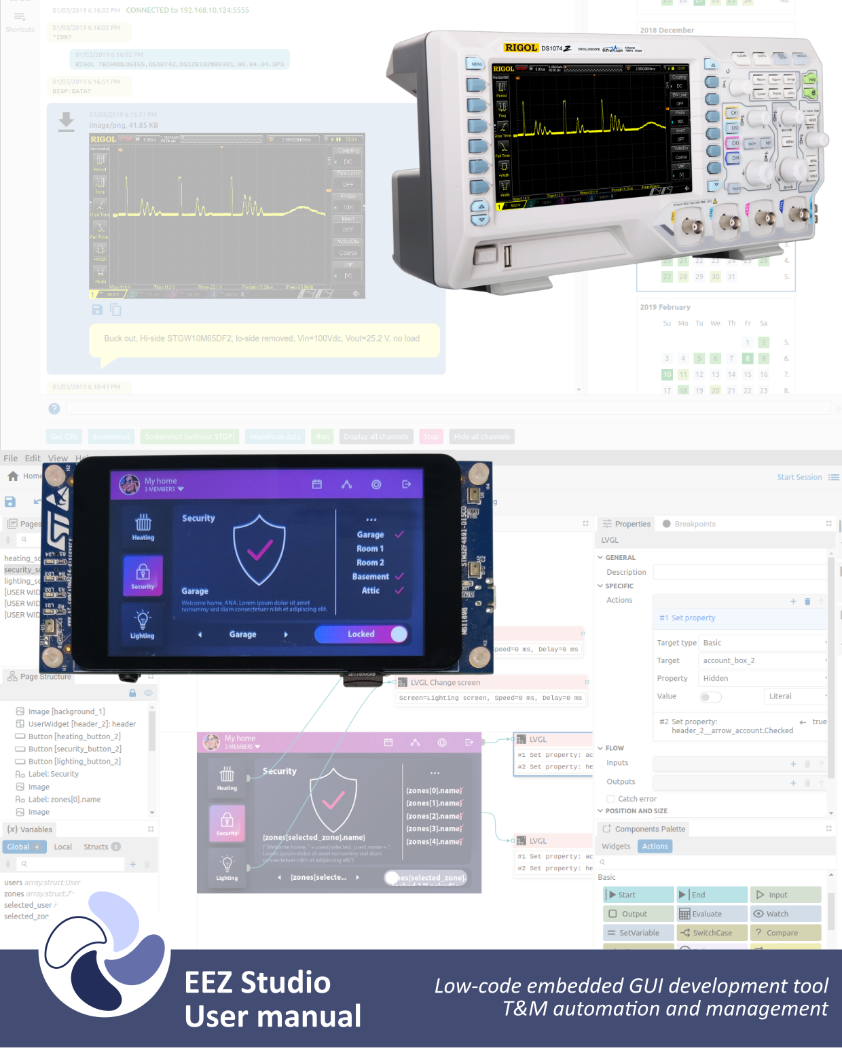
Ver. M14 DRAFT – 05/2023
www.envox.eu
github.com/eez-open

